**2610 Peel Low-Res Mexican Hat Computational Analysis and Automation Methodology**   
  
Section 1: Introduction

Accurately determining the age of barnacles is crucial for ecological studies, population modeling, and environmental monitoring. Traditional methods, such as counting external shell rings, often fail to provide precise age estimations due to the variability in ring formation and environmental influences. This study aims to address these limitations by employing advanced imaging techniques to analyze internal growth lines, offering a more reliable approach to age determination.

Barnacles exhibit periodic growth increments in their calcareous plates. These increments, visible under high-resolution imaging, have been traditionally counted manually using light microscopy. However, this method is labor-intensive and prone to human error, especially in specimens with closely spaced or faint growth lines. Recent advancements in imaging technology, such as scanning electron microscopy (SEM), have enhanced the visibility of these growth lines, allowing for more accurate and efficient analysis.

The *Lepas anatifera* or Goose barnacle shell consists of five plates: a pair of scuta, a pair of terga, and a dorsal carina. Among these, the alae and the sheath–ala complex are particularly rich in growth lines. These barnacles are filter feeders, utilizing their cirri to capture plankton and detritus from the water. The internal growth lines serve as reliable indicators of age. Traditional methods involve manual counting of these lines under light microscopy. When sectioned and imaged, these plates reveal distinct growth patterns that leave a biological code for age determination studies.

In this study, we collected barnacle samples from the intertidal zone and prepared them for SEM analysis. The specimens were sectioned to expose the internal growth structures and analyzed under an SEM, we captured high-resolution images of the growth lines within the alae and sheath regions. These images were then processed using ImageJ software, applying a sequence of filters to enhance contrast and delineate growth increments. A novel Python algorithm was employed to automate the counting of these increments, ensuring consistency and reducing observer bias.

In this study, we hypothesize that utilizing SEM imaging combined with automated analysis will provide a more accurate and reproducible method for determining the age of barnacles compared to traditional light microscopy techniques. Preliminary results indicate that this approach yields consistent age estimations across multiple specimens, supporting the efficacy of this methodology.  
  
Section 2: Technical Overview

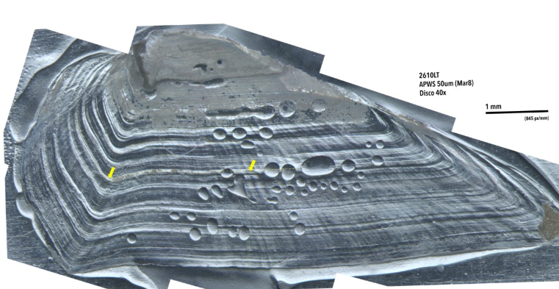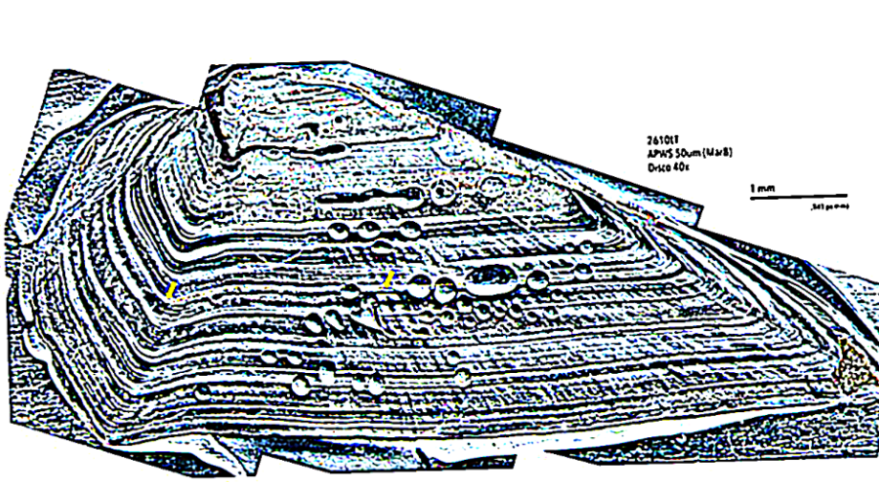

Figure 1: Transition from the Disco-Image (Left) to the Mexican-Hat Image (Right)

Image Pre‑processing

Open the barnacle PNG file of a 40xDisco filter set to 50p and 300dpi in ImageJ and apply three filters in sequence. First, run Enhance Contrast with “Equalize Histogram” checked to make subtle growth lines more visible. Second, use Process → Noise → Despeckle to denoise and account for the random variation of the contrast tool. Third, apply the Mexican Hat filter (Plugins → Filters → Mexican Hat) to convert the gray values into a binary distribution. This exact order—contrast, despeckle, Mexican Hat—maximizes peak‑to‑valley distinction without erasing any important data. The output image will now look like the right image of Figure 1.

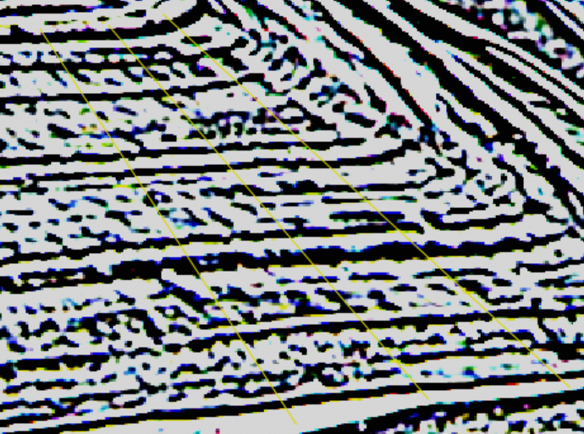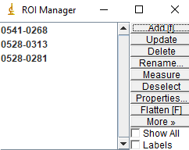  
Figure 2: Setting Three Lines on the Image (Left) and the ROI Manager (Right)

2.1 Line Placement  
Using the Straight tool, draw a line across the region of interest so that it begins and ends just beyond the outermost increments and crosses each growth band relatively perpendicularly. A single, well‑positioned line ensures the gray‑value profile captures every increment. For more data sets across one sample image, as shown in Figure 2, utilize the Region of Interest (ROI) Manager via command T and click “Add [t]” to set multiple lines, keeping them as parallel as possible for more accurate cross referencing.

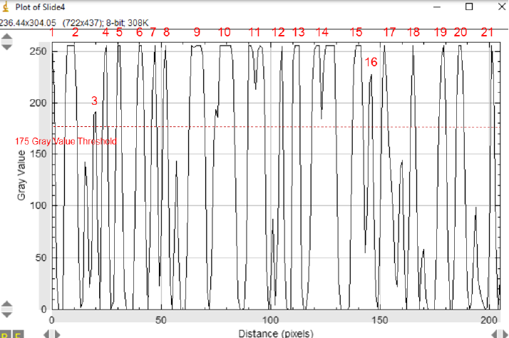

Figure 3: Manually Counted Gray Value Graph Output

2.2 Graph Generation and Peak Counting  
Generate the gray‑value profile for the drawn line (Analyze → Plot Profile). In the resulting plot, each peak corresponds to a black band and each valley to a white band—together marking one growth increment. For smaller sample sizes, as shown in Figure 3, manually count the peaks (or peak‑valley pairs) in this graph. This can be done by setting a determined threshold value and counting every peak that reaches above it, and none of the peaks below it. You now have your estimated age of the barnacle.

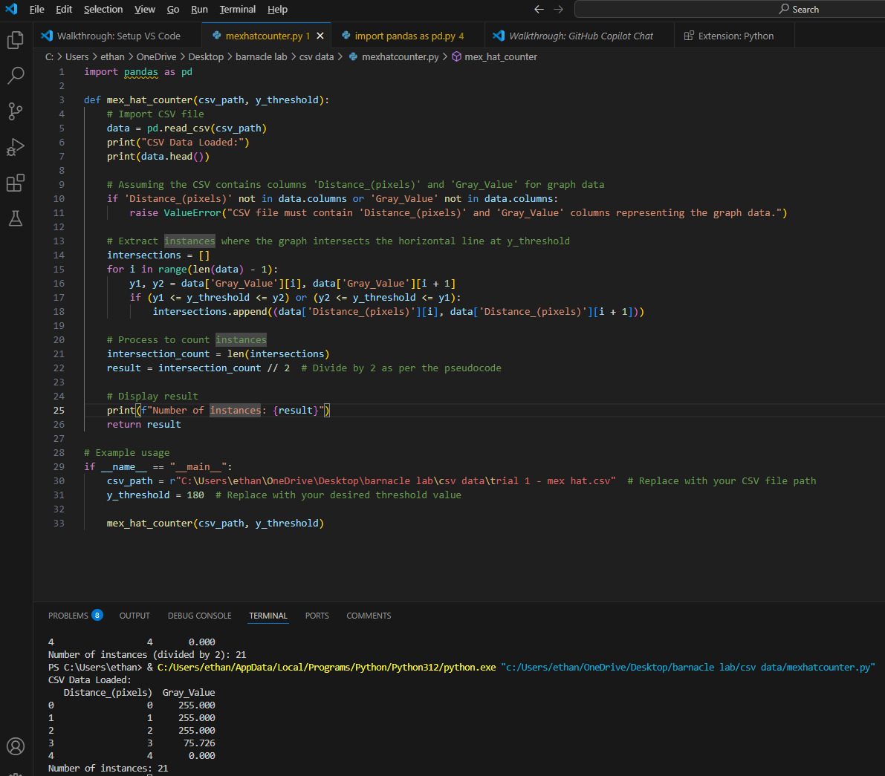

Figure 4: Python script to count growth increments

2.3 Python Integration  
For larger data sets, semi-automation may be used via the MexHatCounter.py program as shown in Figure 4. Export the plot data from the gray value graph as a CSV and import it into your Python script by setting the path location. The script reads the intensity values above the set threshold value, counts the increments that reach this, and returns the estimated age of the barnacle.

Section 3: Discussion  
In this study, we present a semi‑automated pipeline for quantifying barnacle growth increments that combines optimized ImageJ pre‑processing, strategic line placement, and Python‑based analysis. It was first determined that applying Contrast Enhancement with histogram equalization, followed by Despeckle and the Mexican Hat filter, maximally distinguished growth lines from background noise. Histogram equalization expanded the gray‑value range to reveal faint bands, Despeckle suppressed random noise due to the contrast filter, and the Mexican Hat filter binarized intensity transitions to produce distinct peaks and valleys.

Next, we set a straight line somewhat perpendicular to the growth bands—extending beyond the outermost increments—to capture each band fully while minimizing curvature artifacts. In the case of collecting multiple data graphs, using parallel lines in parallel further improved consistency. Gray‑value profiles extracted along these lines were analyzed by counting peak‑valley pairs, with pre‑processing steps rendering most features sufficiently pronounced for reliable semi‑automated detection. Occasional residual noise in high‑resolution images indicated the need for adaptive smoothing in future implementations.

Finally, we exported the profile data as CSV for Python scripting, where maxima detection yielded total increment counts that matched manual observations (e.g., 21). The congruence between manual and script counts validates the pipeline’s quantitative accuracy. Future work will integrate AI‑driven ROI selection and Weka‑based segmentation to automate line placement and further reduce user bias.

Section 4: References

Burden, D. K., Spillmann, C. M., Everett, R. K., Barlow, D. E., Orihuela, B., Deschamps, J. R., Fears, K. P., Rittschof, D., & Wahl, K. J. (2014). Growth and development of the barnacleAmphibalanus amphitrite: time and spatially resolved structure and chemistry of the base plate. *Biofouling*, *30*(7), 799–812. <https://doi.org/10.1080/08927014.2014.930736>

Crisp, D., & Bourget, E. (1985). Growth in Barnacles. *Advances in Marine Biology*, *22*(0065- 2881), 199–244. <https://doi.org/10.1016/S0065-2881(08)60052-8>

Varfolomeeva, M., Artemieva, A., Shunatova, N., & Yakovis, E. (2008). Growth and survival of barnacles in presence of co-dominating solitary ascidians: growth ring analysis. *Journal of Experimental Marine Biology and Ecology*, *363*(1-2), 42–47. <https://doi.org/10.1016/j.jembe.2008.06.012>